Aim  
To create a Virtual Hard Disk and allocate storage for a Virtual Machine using Oracle VM VirtualBox.

**Procedure**

1. Launch Oracle VM VirtualBox
   * Open the VirtualBox application on the host machine.
2. Start Creating a New Virtual Machine or Modify an Existing One
   * Click New to create a new VM or select an existing VM and go to Settings → Storage.
3. Open Virtual Hard Disk Creation Wizard
   * When creating a new VM, after naming and assigning RAM, you are prompted to create a virtual hard disk.
   * Select Create a virtual hard disk now and click Create.
4. Select Hard Disk File Type
   * Choose VDI (VirtualBox Disk Image) as the disk file type and click Next.
5. Choose Storage on Physical Hard Disk
   * Select between:
     + Dynamically allocated (grows in size as data is added up to the max on disk)
     + Fixed size (allotted storage size is reserved immediately)
   * Click Next.
6. Set Disk Size
   * Enter the desired disk size in GB (e.g., 15 GB).
   * Choose the location where the virtual disk file will be saved (can be default).
   * Click Create.
7. Verify Virtual Disk Allocation
   * The virtual hard disk is now created and attached to the VM as specified.
   * You can verify the disk under Settings → Storage in VirtualBox.

**Output:**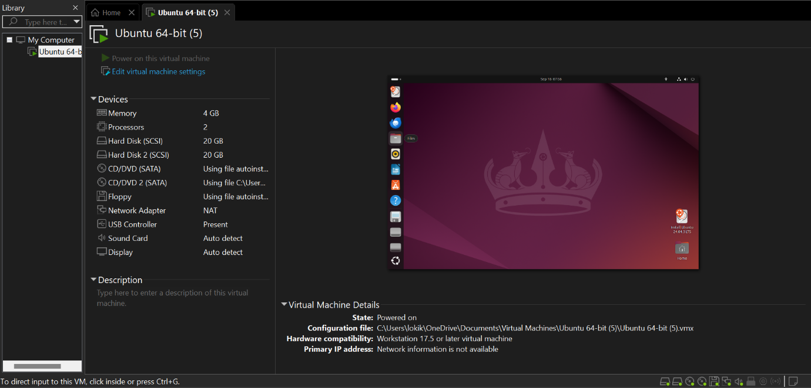

**Result**

A Virtual Hard Disk was successfully created and storage was allocated using Oracle VM VirtualBox. The disk type (VDI) and size (e.g., 15 GB) were configured as required, and the virtual disk is ready to be used by a virtual machine.